|  |  |  |  |  |  |
| --- | --- | --- | --- | --- | --- |
| **S.NO.** | **SENDER’S DOMAIN** | **EMAIL PROTOCOL** | **DATE/TIME SENT** | **TIME ZONE** | **GEOLOCATION** |
| 1. | .ru | ESMPTS | 06 Sep 2023, Wed 17:06:10 | UTC+03:00 | UN |
| 2. | .org | SMPTS | 22 Mar 2023, Wed 07:51:50 | CDT-05:00 | UN |
| 3. | .com | SMTP | 09 Jul 2023, 05:07:01 | GMT +5:30 | US |
| 4. | .com | LSMTP | 09 Aug 2023, 09:47:58 | GMT +5:30 | US |
| 5. | .com | ESMPTS | 18 Apr 2021, 05:22:09 | GMT +5:30 | France |

**LAB EXPERIMENT – 2**

**EMAIL HEADER ANALYSIS**

**BONUS**

**There are three methods of EMAIL AUTHENTICATION:**

* SPF (Sender Policy Framework) : It allows email senders to stipulate the IP addresses allowed to send mail for a specific domain. SPF helps to harden your DNS servers and limit those who use your domain to send emails.
* DKIM (DomainKeys Identified Mail) : It offers an encryption key and digital signature that confirms an email is authentic and not faked or modified.
* DMARC (Domain-based Message Authentication, Reporting, and Conformance): It offers directions on what the receiver should do if a message from a domain fails the authorization test.  The email receiver can reject or junk such an email. Unlike SPF and DKIM that can be employed as stand-alone methods, DMARC depends on SPF or DKIM to offer authentication.

ONLY **SPF** IS PASS IN EMAIL AUTHENTICATION

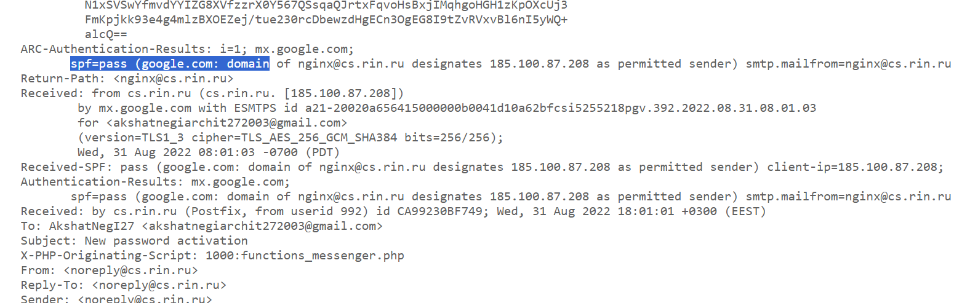



In this **SPF**, **DKIM** & **DMARC** all three are passed fully Authenticated.

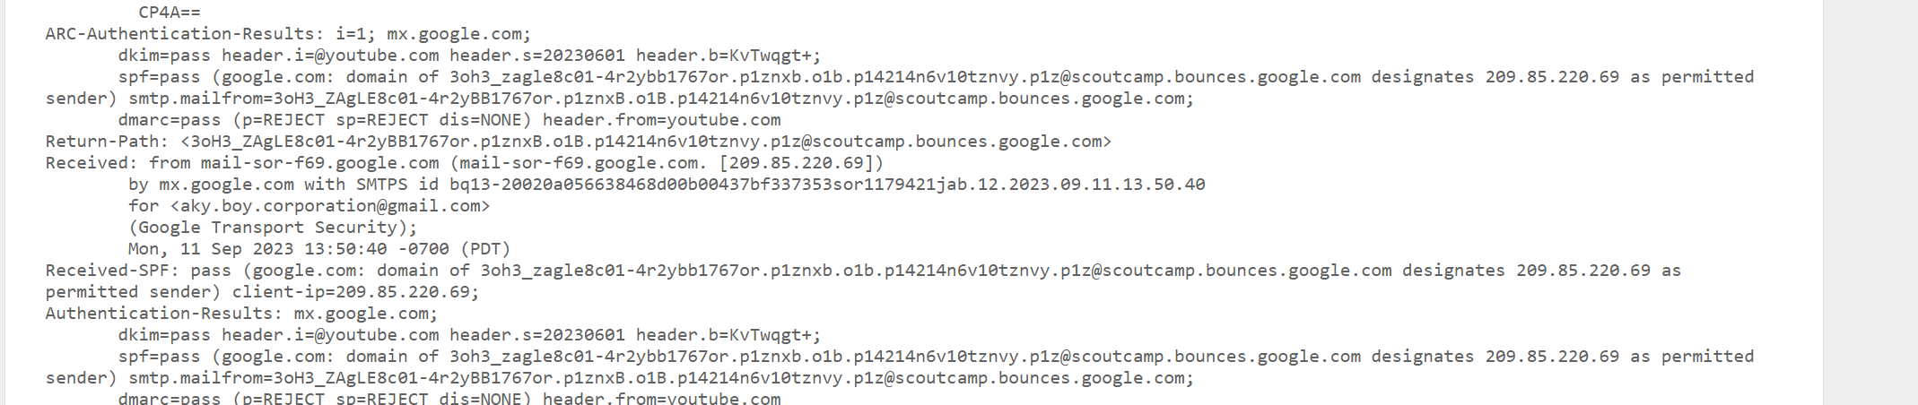



**EMAIL 1**

**GMAIL ORIGINAL HEADER VIEW**

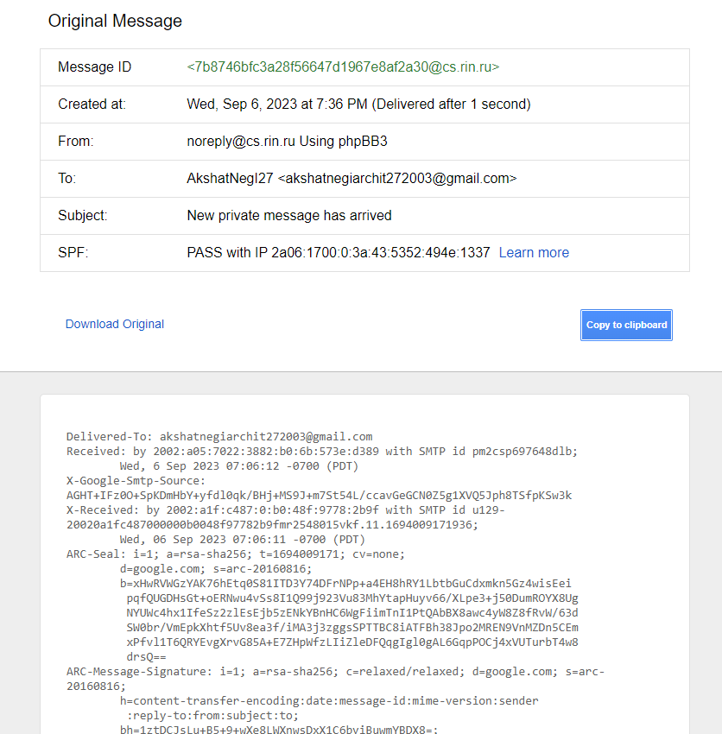

**https://toolbox.googleapps.com/**

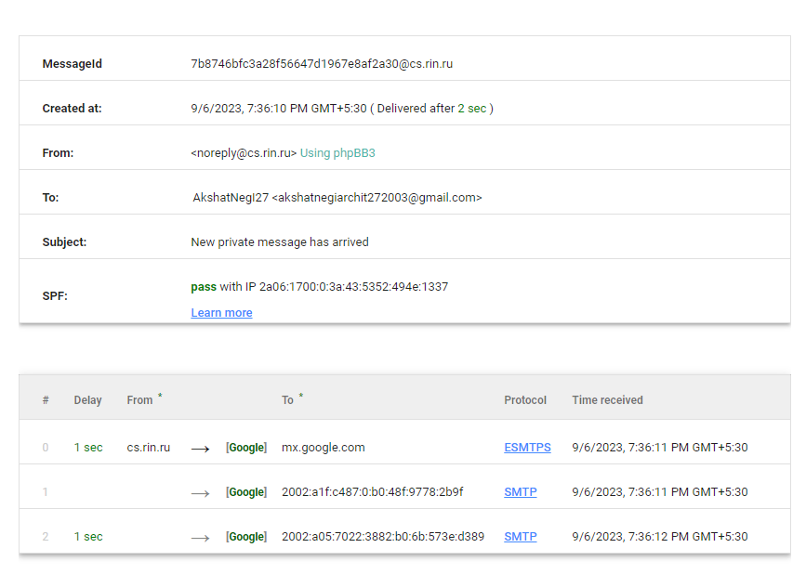

[**https://whois.domaintools.com/**](https://whois.domaintools.com/)

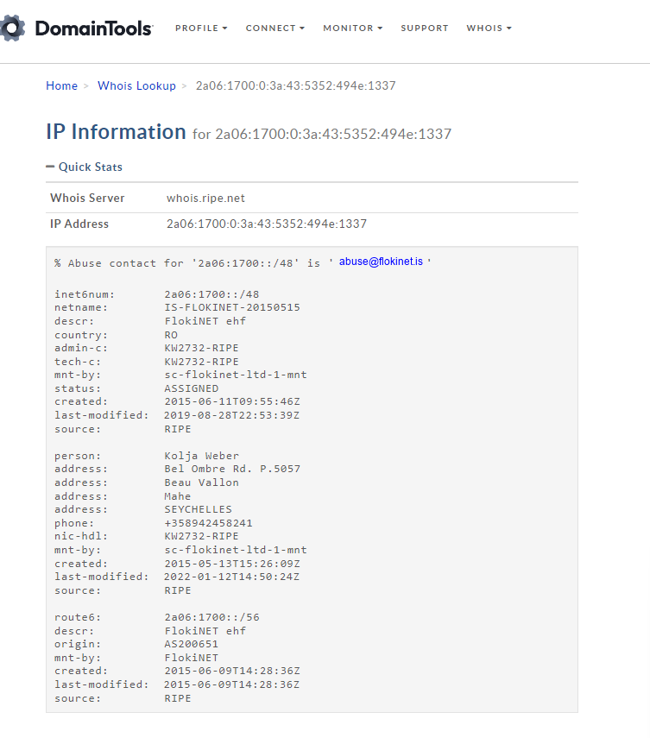

**https://mxtoolbox.com/**

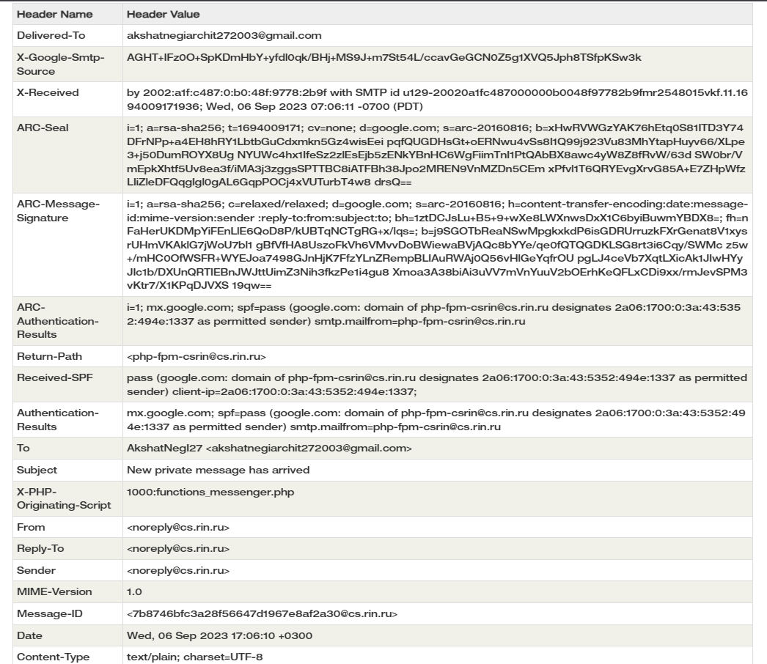

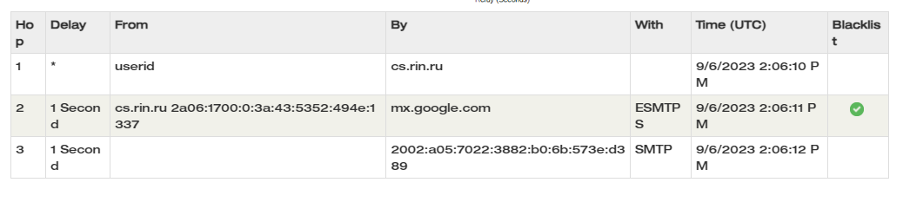

**EMAIL 2**

**GMAIL ORIGINAL HEADER VIEW**

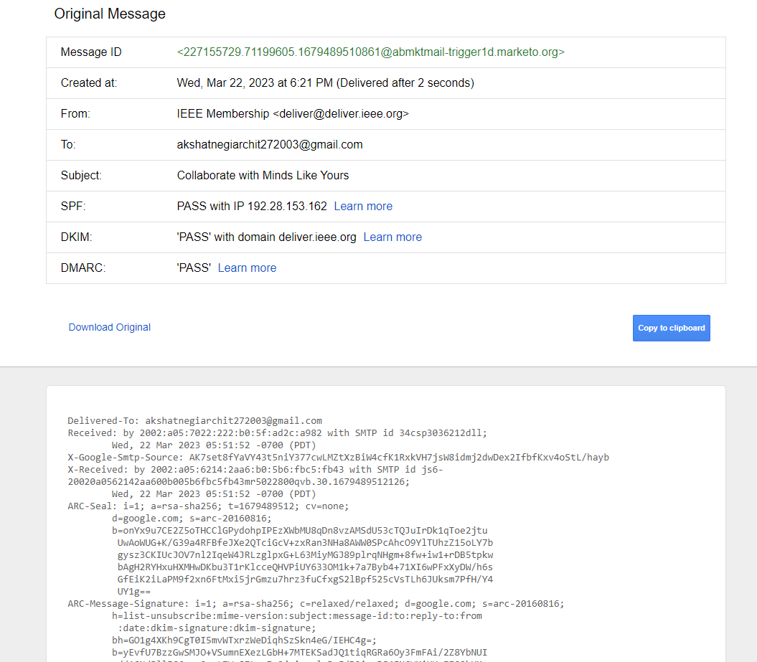

**https://toolbox.googleapps.com/**

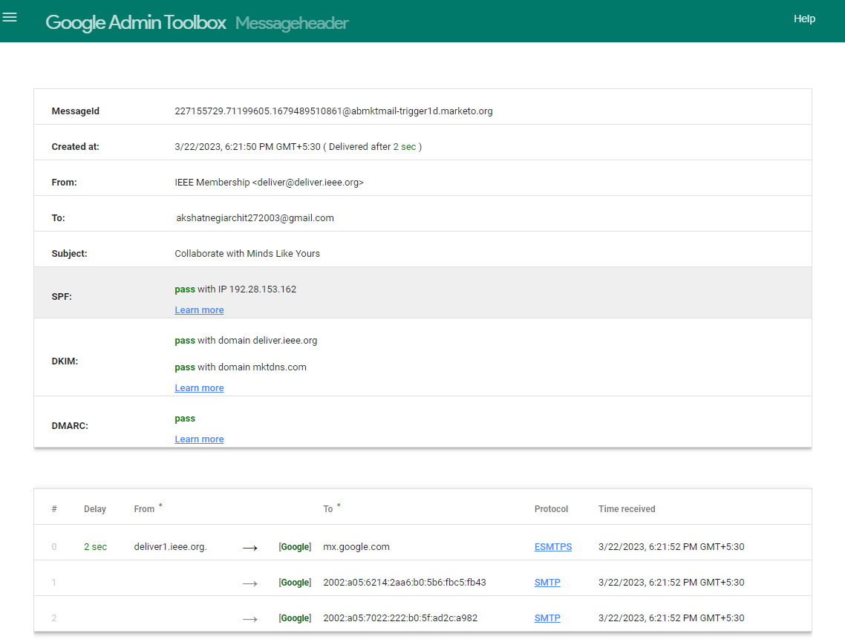

[**https://whois.domaintools.com/**](https://whois.domaintools.com/)

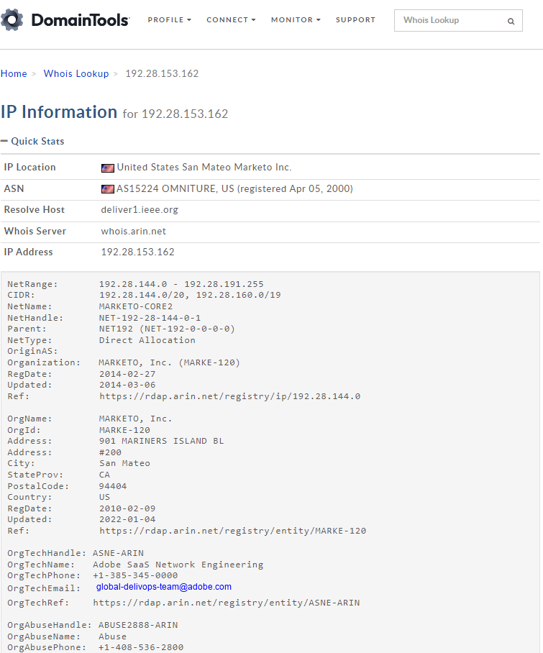

**https://mxtoolbox.com/**

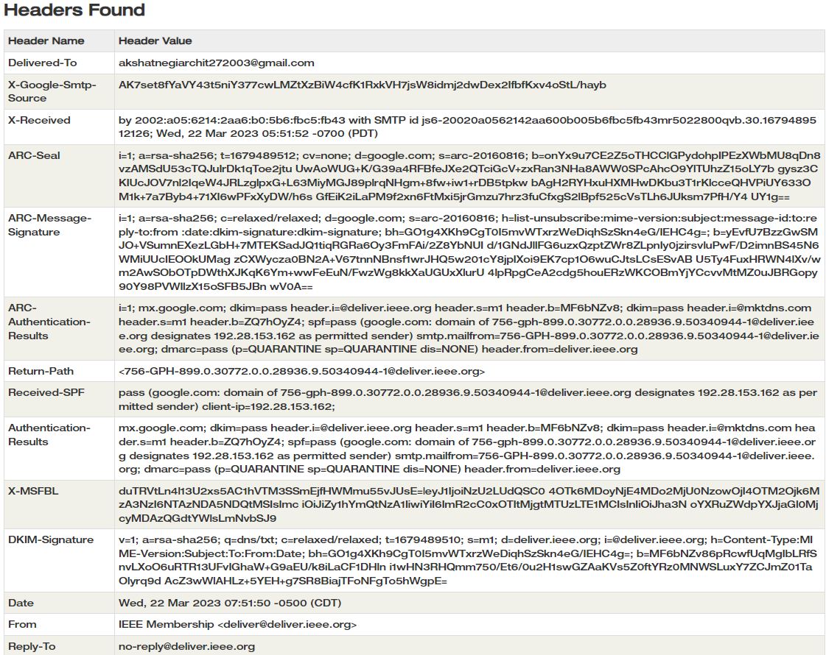

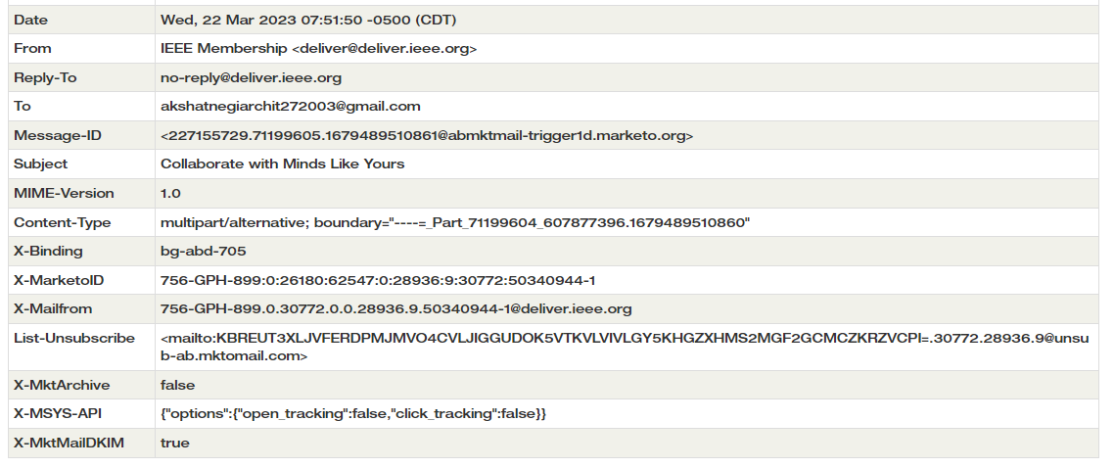

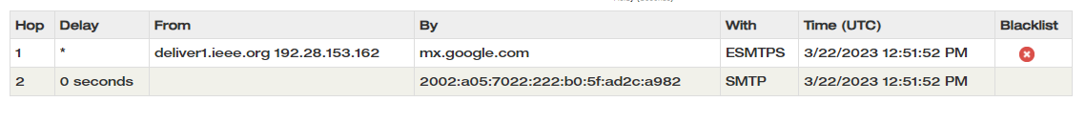

**EMAIL 3**

**OUTLOOK ORIGINAL HEADER VIEW**

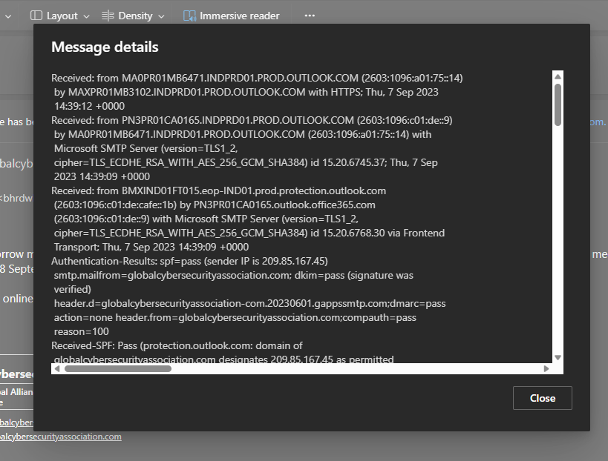

**https://toolbox.googleapps.com/**

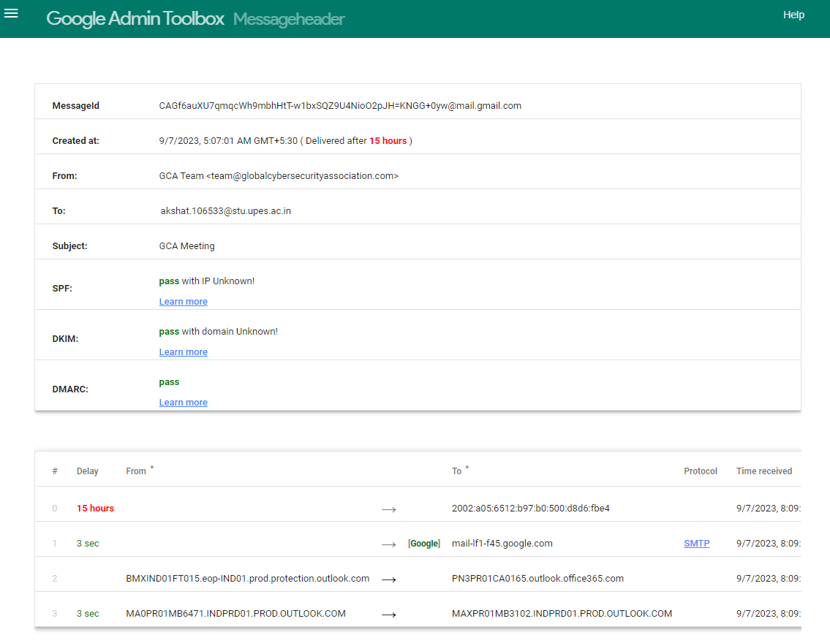

[**https://whois.domaintools.com/**](https://whois.domaintools.com/)

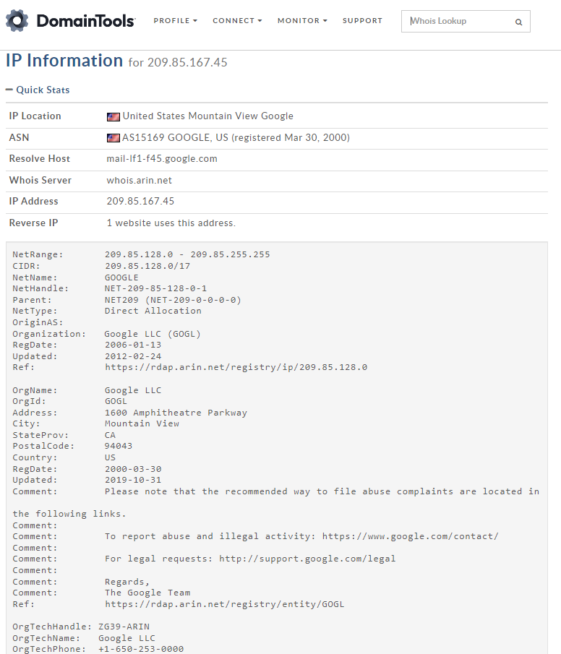

**https://mxtoolbox.com/**

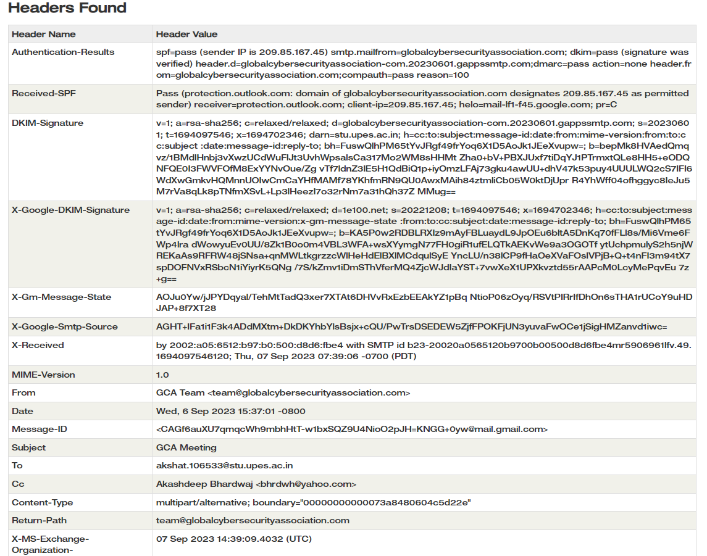

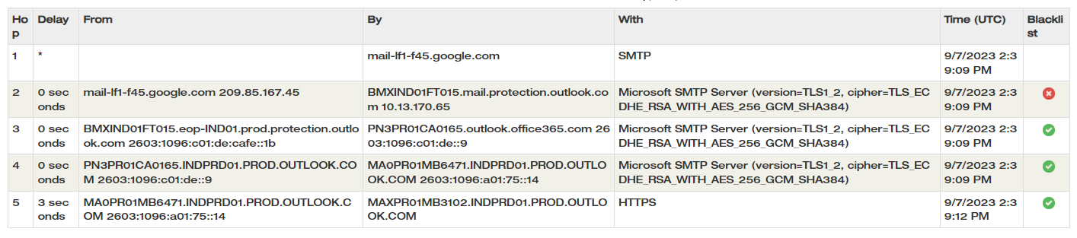

**EMAIL 4**

**OUTLOOK ORIGINAL HEADER VIEW**

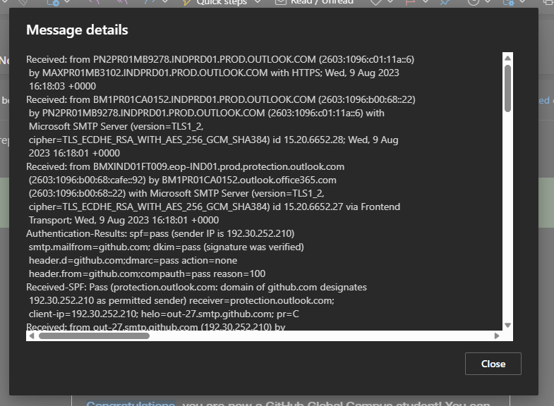

**https://toolbox.googleapps.com/**

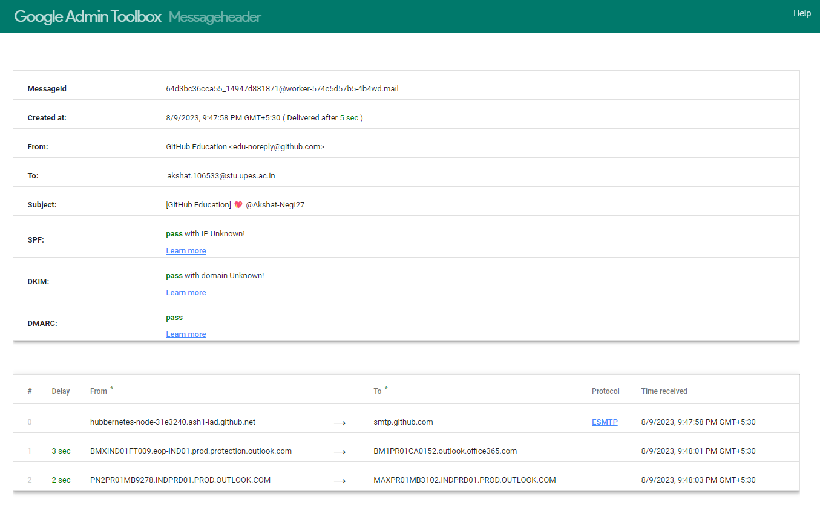

[**https://whois.domaintools.com/**](https://whois.domaintools.com/)

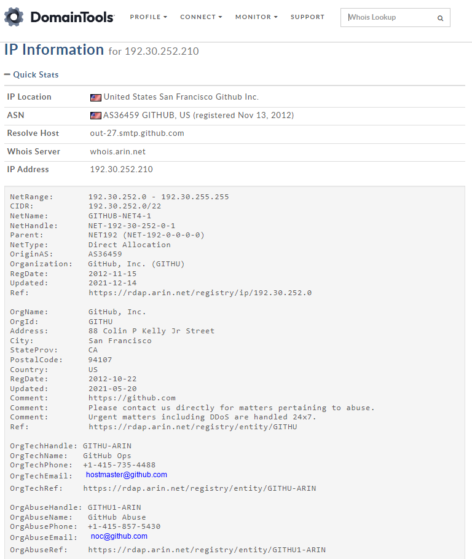

**https://mxtoolbox.com/**

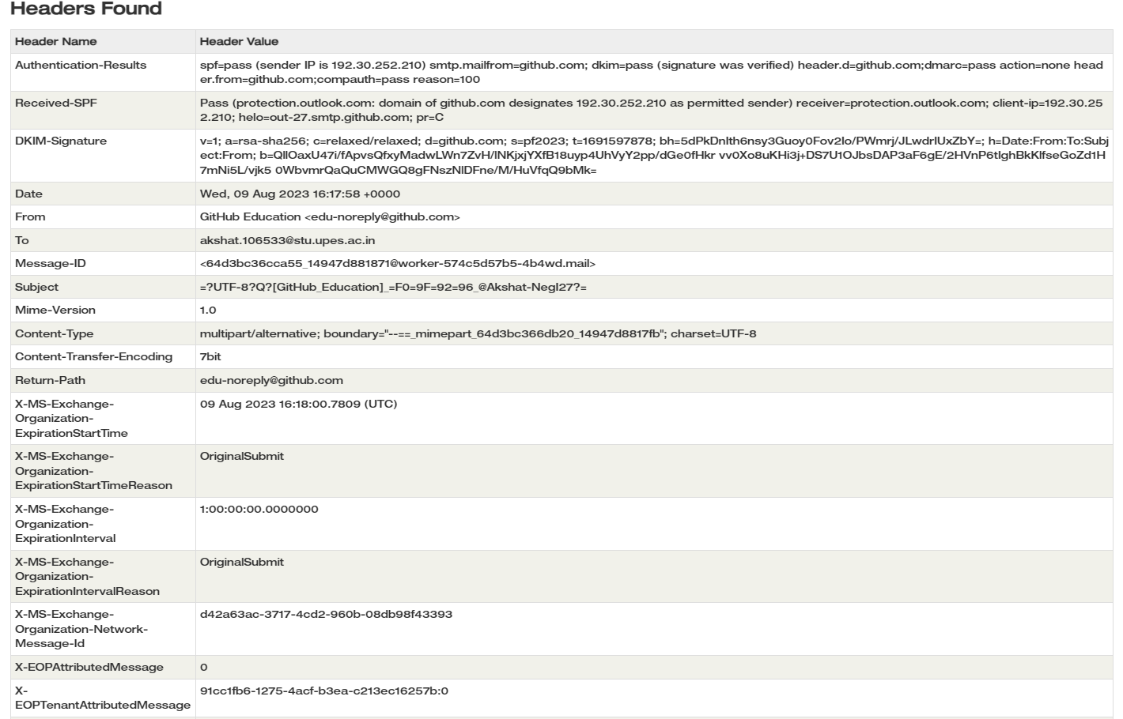

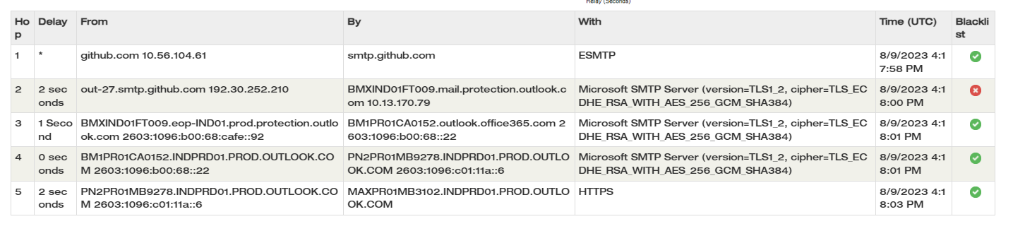

**EMAIL 5**

**OUTLOOK ORIGINAL HEADER VIEW**

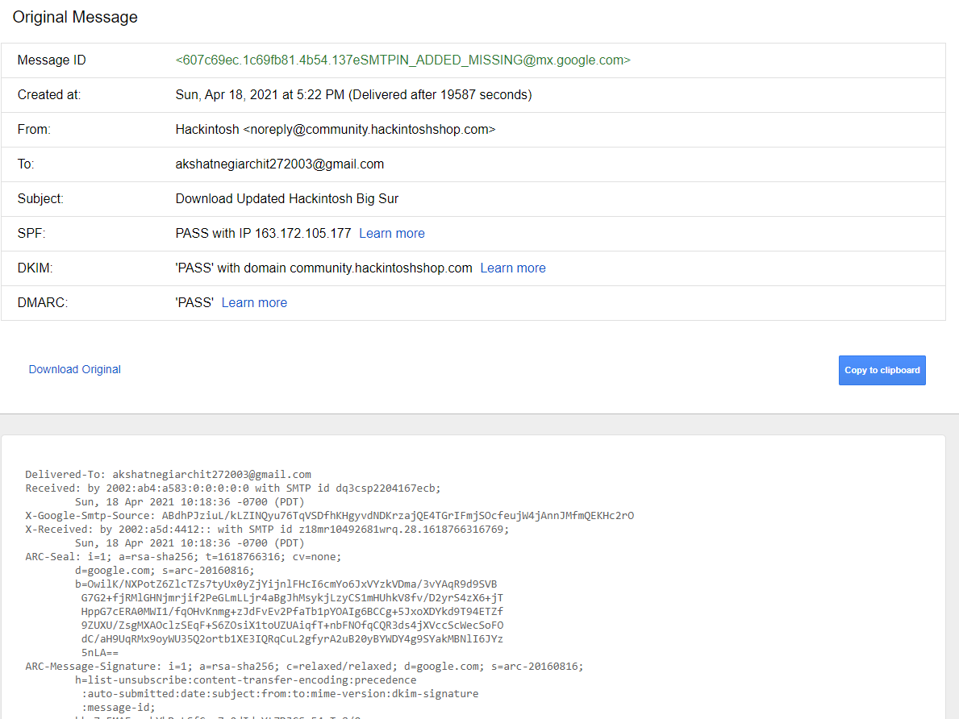

**https://toolbox.googleapps.com/**

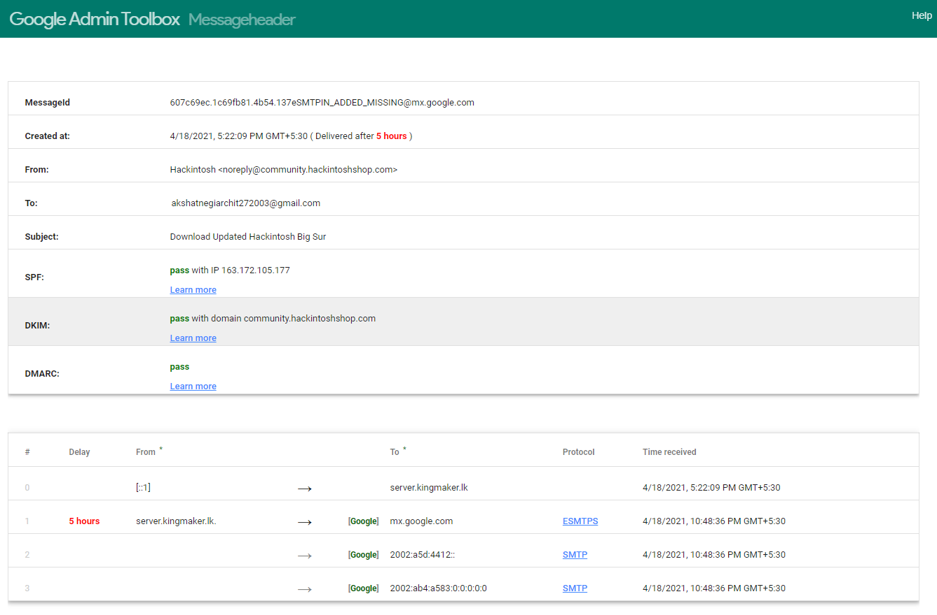

[**https://whois.domaintools.com/**](https://whois.domaintools.com/)

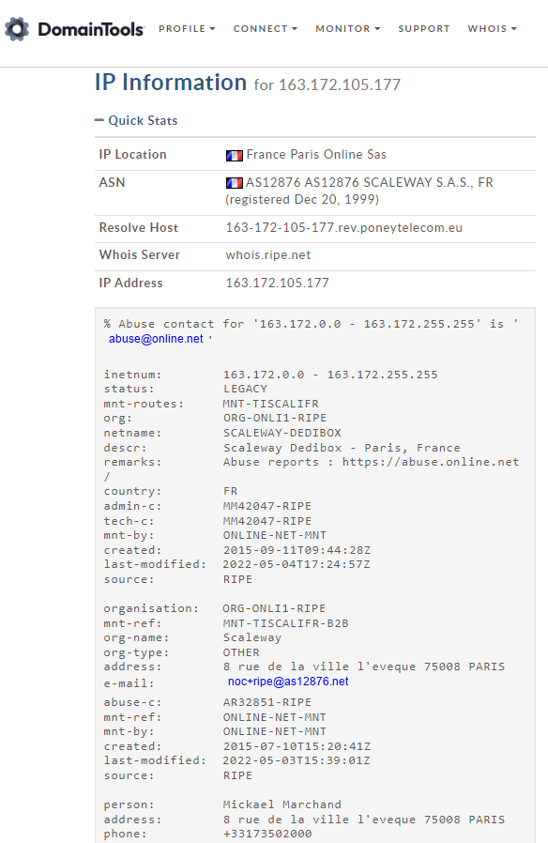

**https://mxtoolbox.com/**

